Name: G.Abhilash

Roll_No:2303A52240

PROMPT ENGINEERING TASK REPORT

Task 1: Cleaning Sensor Data

Prompt:

Give a function that filters out all the negative numbers from a list.Explanation
As the prompt becomes more specific, the calculator logic improves by handling operators correctly and preventing division by zero.

Code
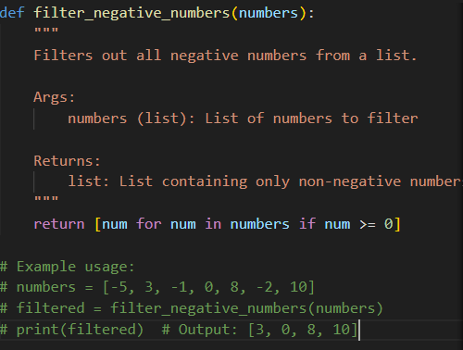

Output
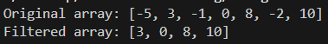

Task 2: String Character Analysis

Prompt

giva a function that counts vowels, consonants,and digits in a string

Code
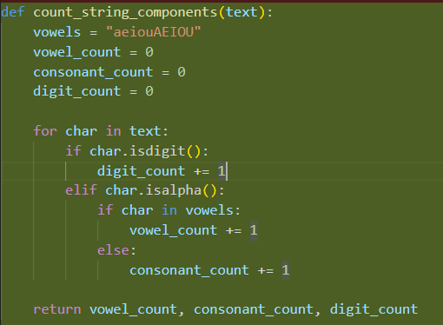

Output
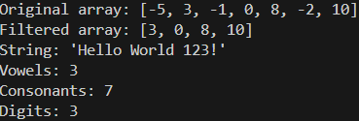

Task 3: Palindrome Check – Tool Comparison

Prompt

give a function that checks the palindrome
.

Code
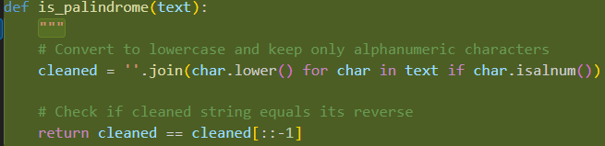

Output
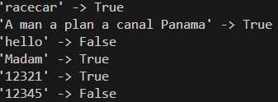

Task 4: Code Explanation Using AI

Prompt
Explain the palindrome code

Code

